**Experiment no – 01 (E)**

**Aim:** Write a function to check the input value is Armstrong and also write the

function for Palindrome.

**Theory:-**

**Practical Implementation**:-

**Code**:-

num = int(input("Enter a number: "))

sum = 0

temp = num

while temp > 0:

digit = temp % 10

sum += digit ** 3

temp //= 10

if num == sum:

print(num,"is an Armstrong number")

else:

print(num,"is not an Armstrong number")

**Output:- 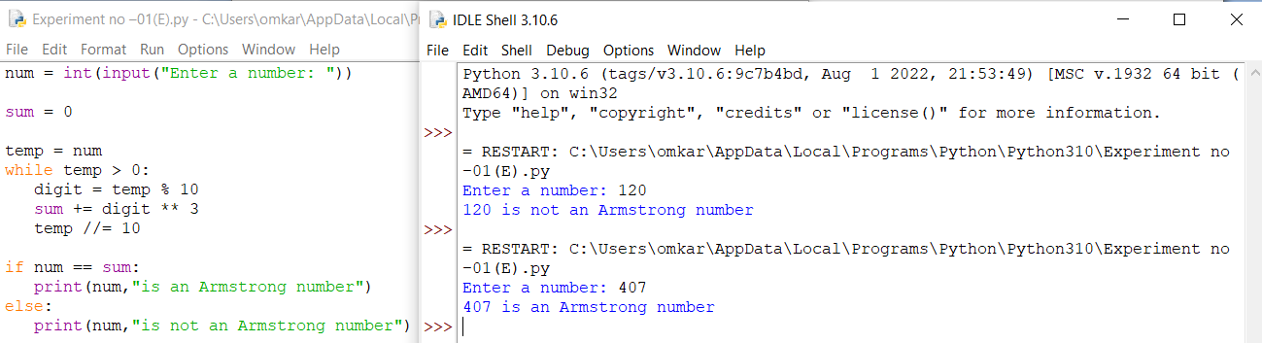Conclusion:-** This is program successfully run.